**PRESS RELASE**

**COMMUNICATIONS AND MEDIA TEAM OF THE 2023 ASEAN SUMMIT**

**No.22/SP/TKM-ASEAN2023/ENG/5/2023**

**National Police Chief: Security Task Force for the 42nd ASEAN Summit Must Know Their Duties**

**West Manggarai, 4 May 2023 –** General Police Listyo Sigit Prabowo, Chief of the National Police, expected the police security task force at the 42nd ASEAN Summit 2023 in Labuan Bajo, West Manggarai, East Nusa Tenggara to be able to comprehend their responsibilities and work together to solve problems.

"We hope that with today's training, each member understands their role, how to coordinate between task forces, and how to communicate when receiving information and orders from leaders in the field or command center," said National Police Chief Listyo following the Tactical Floor Game (TFG) Operation Komodo-2023 in the context of securing the 42nd ASEAN Summit at the Regional Secretariat Hall of the West Manggarai Regency Government on Thursday, 4 May.  
  
In order to secure the 42nd ASEAN Summit, the TFG Operation Komodo-2023 involved a total of eight security task forces. The eight task forces are the Preemptive Task Force, the Preventive Task Force, the Action Task Force, the Rolakir Task Force, the Public Relations Task Force, the Banops Task Force, the Gakum Task Force, and the Anti-Terror Task Force.  
  
According to the National Police Chief, the training was a to prepare for a security arrangement plan to be implemented jointly with the Indonesian National Armed Forces/TNI. According to Listyo, there were several issues expressed regarding the task force's responsibilities.

Therefore, he expected that the provided training would serve as a guide for the task force members to comprehend their role in solving the problem.  
  
"How to act and coordinate with other task forces and TNI personnel within Ring 1. During the implementation of the Joint TFG, more comprehensive training will be provided,” he said

The National Police Chief expected every member to be able to communicate effectively with fellow officers both in the field and command center.

“All of this can, of course, help us prepare for security measures that we will implement in the coming days,” he emphasized.

Previously, the National Police Chief stated that there will be traffic engineering during the implementation of the 42nd ASEAN Summit 2023 in West Manggarai, so the public is asked for their cooperation when the policy is enforced.

"Of course, there will be traffic diversions," he said in a written statement after inspecting the readiness of the 91 command centers in Labuan Bajo on Wednesday, 3 May.

Sigit acknowledged that this traffic engineering policy would undoubtedly disturb the comfort of community activities. He asked for understanding and apologized if the diversion of traffic disrupted the smooth flow of traffic in the community.

"Therefore, with regards to the discomfort of the community that may be caused by the traffic diversion, we sincerely apologize," he said. (France Mariana Nuka ANTARA/TR/Elvira/SC)

***

For more information, please contact:

Director General of Public Information and Communications of the Ministry of Communications and Informatics – Usman Kansong (0816785320).

Get other information at <https://infopublik.id>

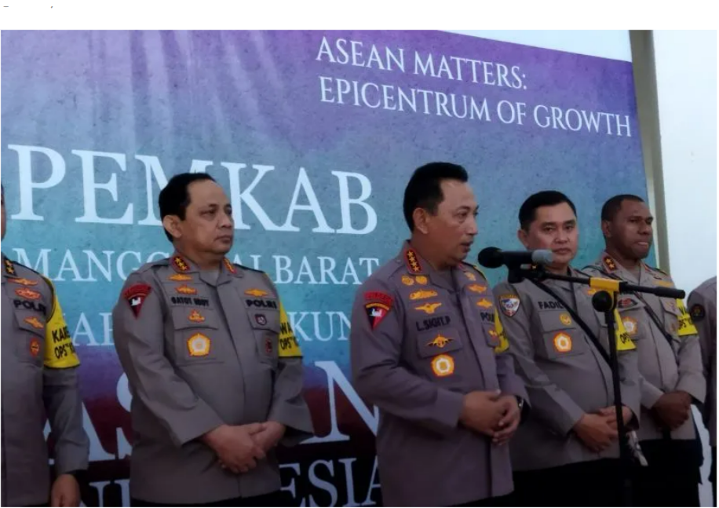

National Police Chief Listyo Sigit Prabowo makes a statement to the press following the Tactical Floor Game (TFG) Operation Komodo-2023 in the context of securing the 42nd ASEAN Summit at the West Manggarai Regency Government Regional Secretariat Hall, Labuan Bajo, NTT, on Thursday, 4 May 2023 (ANTARA/Fransiska Mariana Nuka)